Kip Taylor

Exam 1

1. No late submission will be accepted.

Instructions

1. You must submit your exam electronically only in .pdf format via Blackboard no later than **11:59 pm February 18, 2020**. Files submitted after this time will be discarded.
2. The university has important rules for exams. Please carefully read the instructions below. Failure to comply with any of the instructions below may result in our being unable to accept or grade your exam or initiating disciplinary actions
3. The exam must be taken completely alone. Showing it or discussing it with anybody is forbidden, including (but not limited to) the other students in the course in current or previous years. It is also forbidden to use any solutions to similar problems from previous years as reference material.
4. Given your final grade depends on your rank in the class, you don’t want to penalize yourself dis- cussing your solutions with the other students.
5. You may use any publicly available material you want, including books, the internet, etc. However, You are NOT allowed to submit questions to internet discussion groups, though!.
6. Show your work. You need to demonstrate your understanding by showing the detail of your work.
7. Consent: By submitting this exam I declare I am aware of the Kent State Administrative Policy Regard- ing Student misconduct and I acknowledge that any academic misconduct on this exam will lead to a grade ”F” for the course and that the misconduct will be reported to the Center for Student Conduct.
8. Consider the layers in TCP/IP reference model (Figure 1.22) of your text Assume that the user data is 1 KB,

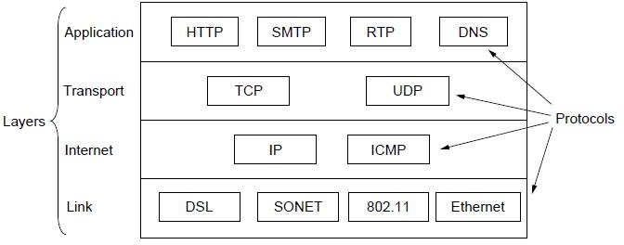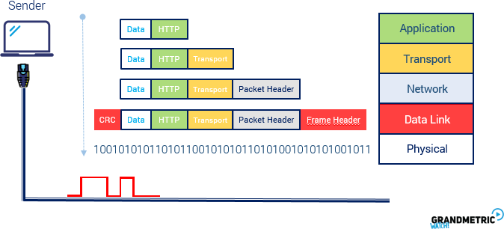

HTTP header is 128 bytes, TCP header is 20 bytes, IP header is 20 bytes, and Ethernet header is 18 bytes. Assume that the maximum payload for Ethernet is 1500 bytes excluding the header.

* 1. Calculate the efficiency of each layer. 5 pts
     1. HTTP

Efficiency = message size / total transmitted data

Answer: **Efficiency =** **1500 -128 / 1500 = .91**

* + 1. TCP

Answer: **Efficiency =** **1500-128-20 / 1500 = .90**

* + 1. IP

Answer: **Efficiency =** **1500-128-20 -20 / 1500 = .88**

* + 1. Ethernet

Answer: **Efficiency =** **1500 -128 -20 -20 -18 / 1500 = .876**

* 1. In practice, the data is much larger than 1 KB. Assume that the data is 6 KB and the payload of Ethernet is only 1500 bytes including its header. Recalculate the efficiency of each layer again. Note that Ethernet has to break large packets into 1500 bytes, hence, more overhead. 5 pts
     1. HTTP

Answer: **6000/(6000 +128) = .98**

* + 1. TCP

Answer:  **6000/(6000 +128 + 20 ) = .98**

* + 1. IP

Answer: :  **6000/(6000 +128 + 20 + 20 ) = .97**

* + 1. Ethernet

Answer: **6000/(6000 +128 + 20 + 20 + 18) = .97**

* + 1. Ethernet

Answer: **6000/6000 + 2( 128 + 20 + 20 + 18) = .94**

* + 1. Ethernet

Answer: **6000/6000 + 3( 128 + 20 + 20 + 18) = .91**

* + 1. Ethernet

Answer: **6000/4(1500+ 128 + 20 + 20 + 18) = .88**

In effect we are transmitting 6000 bytes but with 4 (128 + 20 + 20 + 18) overhead which results in

*×*

6000*/*4(1500 + 128 + 20 + 20 + 18) = 0*.*84

* 1. Explain which layer is End-to-End (E2E) connection and which layer is Point-to-Point (P2P) connection and why? 5 pts
     1. HTTP
* Answer: **HTTP is Point-to-point because a transaction based (HTTP) peer-to-peer protocol for the dissemination of Web-objects in congested networks**
  + 1. TCP
* Answer: **TCP uses an end-to-end flow control protocol to avoid having the sender send data too fast for the TCP receiver to receive and process it reliablity.**
  + 1. IP

Answer**: internet Protocol (IP) is a connectionless datagram service with no delivery guarantees. On the internet, IP is used for nearly all communications.End-to-end acknowledgment and retransmission is the responsibility of the** c**onnection-oriented Transmission Control Protocol (TCP) which sits on top of IP.**

* + 1. Ethernet
* Answer: **Ethernet is point-to-point because of this service is a private data connection securely connecting two or more locations with Ethernet data speeds.**
  1. Explain which layer is connection-oriented and which layer is connection-less-oriented and why?. 5 pts
     1. HTTP

Answer: **Http is a connectionless protocol , due to once a single http request is serviced the connection is closed and not reused. HTTP request are not TCP Data units , so that TCP is connection oriented which respect to TCP protocol data units doesn't stop HTTP from being connectionless with respect to HTTP protocol data units.**

* + 1. TCP
* Answer: **The TCP protocol is a connection oriented protocol because it requires a logical connection to be established between the two processes before data is exchanged.**
  + 1. IP

Answer: **Internet Protocol (IP) is a connectionless protocol that manages addressing data from one point to another, and fragments large amounts of data into smaller, transmittable packets.**

* + 1. Ethernet

Answer: **The Ethernet is a connectionless oriented protocol because Upper layer protocols like TCP establishes connection which is implemented through software and connection oriented Ethernet is also there but by default Ethernet is connectionless.**

Show the detail of your work.

1. During the pandemic, remote communication tools such Zoom, Blackboard, Team, etc. became the only option for remote instruction with some hurdles including scalability. All these technologies are based on a client- server architecture, in which multiple clients communicate to a video server via the Internet. From user’s (client) perspective, delay/latency is the major performance factor, but where are the causes of delay? The delay can incurred by the server due to its load, and by links due to the amount of traffic load on each link.

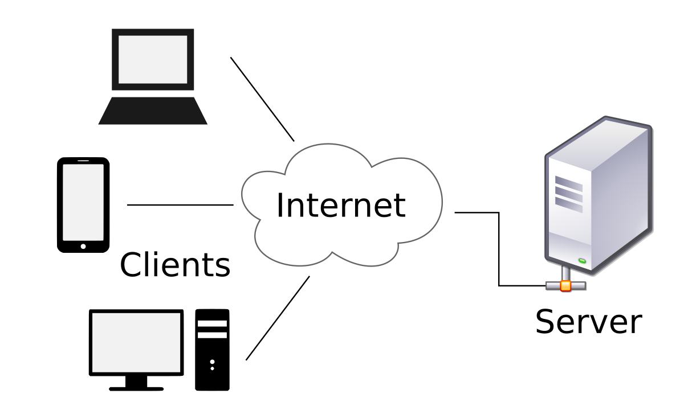

Each link is associated with a buffer (queue). From queuing theory the queuing delay for each queue is formulated by 1*/*(*µ λ*), where *λ* is the rate of packet (frame) arrival per second, and *µ* is the delivery speed of the link in packets/sec.

*−*

Assume the server displays 32 video frames per second per client (connection), and each frame is 1024 x 1024 pixels, and each pixel is 16 bits. Assume also the server’s speed is 4 Gbps (4 *×* 230) bps.

* 1. How many clients can be supported by the server. 7 pts

Answer: **first we get the frames per second for each client then we multiply that by the pixels per frame then we multiply by the bits per pixel and we end up getting 2^29 , and then we server speed/ 2^29 , finally we end up getting 4*2^30.2^29 = 8 clients.**

* 1. Assume we use mpeg4 with 50:1 compression rate, how many clients can be supported. 5 pts

Answer:  **50:1 compression simply means that the total bits transferred is reduced by 50, so we do 8*50 = 400 or the total number of transmission available.**

* 1. Assume the server serves 100 clients with compression, and the Internet delay is negligible, then how much the queuing (buffer) delay is per link 8 pts
     1. From the server to a client

Answer: **1/ (64-16) seconds = 1/48 = .0208 seconds per link**

Math: Total number of frames per second (per connection) sent by server (mu) = 32 frames per second per link , Link speed = 232 bits per second. One frame = 210x 210 x 16 bits = 226 bits. Hence, maximum possible frames per second = (232 bits/second)/(226 bits/frame)*100 (since 100:1 compression is there)= 6400 frames per second. Per link, this becomes 64 per frames per second per link (since there are 100 links).

ii. Froma Client to a server :

Answer: **1/ (64-16) seconds = 1/48 = .0208 seconds per link due to client to server in this scenario is the same as server to client**

**All of this assuming compression is 100 to 1 since it wasn’t stated that it was 50:1**

1. Consider a noisy 10 MHz channel with a signal-to-noise ratio of 20 dB. 5 pts each
   1. What is the maximum data rate of this channel.

**Answer: SNR from db to ratio is equal too 10 log 10 ( SNR) or 10^2 = 100**

**Shannon Capacity = Bandwidth * log2(1 + SNR) or 10* 6.6582 =**

**66.582 Mbps = max rate**

* 1. What is the maximum data rate of the channel when there is no noise and we are transmitting 8 bits at a time.

**Nyquist Bit rate = 2 * bandwidth * log2(L)= 2*10*log2(8) = 60 Mbps**

* 1. Can we use *C* = *B* log2(1 + *S/N* ) and assign *N* = 0 for a noiseless channel? If yes, how?

If no, why?

**No due to channel being noiseless making n = 0 undefined cant use Nyquist , also shannons cant be used in a noiseless channel**

* 1. Is signal-to-noise ratio of 20 dB adequate to transmit 100 Mbps on this channel? Explain why? Show the detail of you work.

**10 MHz *log(1+snr(100) > than 100Mbps**

**So , no 20 db should not be good to transmit 100 mbps on this channel due to SNR in db < than whats needed, to make it work we need SNR to be greater than 10*log10(1023) or 30.099 dB for the channel.**

1. Consider a 25 MHz noise-less channel between two nodes that are 100 km apart. Assume that we send 4 bits at a time. Assume that the speed of light is 2 108 meters/s. For calculation simplicity, we use 1 Mbps = 106 bps instead of 220bps.

*×*

5 pts each

* 1. What is the length of one bit in time on this channel?

Answer: **so ,bit rate = 2* Bandwidth*log2(L)**

**Or 100 Mbps = 10^8 bps, length of one bit in time = 1/bitrate or 10 nanoseconds**

* 1. What is the length of one bit in meters on this channel?

**Propagation Speed / Bandwidth = 2*10^8 / 10^8 = 2 meters**

* 1. Now, consider a frame (packet) of 1 KB (10^3 bytes), what is the length of the packet in time and in meters?

**So, The length of packet = 10^3 / bitrate or 10^3 / 10^ 8 or 1/10^5 = 10 microseconds = time part**

**Then, distance = we take length of bit *10^3 = 2m * 1000 = 2000m, or 2 km.**

* 1. How long does it take to transmit the packet over the 100 km distance from the time the first bit is trans- mitted to the time the last bit is received.

**We need to calc the delay time to figure the time to get there**

**Total time = Propagation delay + transmission delay**

**T delay - length of packet in time or 10 microseconds**

**Prop delay = distance / speed , 100km / 2*10^8 = 50 / 10^5 seconds = 500 microseconds , + 10 micro = total delay = 510 microseconds .**

1. We have 10 users sharing a 100 Mbps channel, which of the multiplexing techniques (FDM, TDM, CDM, and WDM) is suitable for each of the following scenarios and why? Assume 1 Mbps = 1 MHz
   1. Each user randomly transmits with an average 50 Mbps and peak rate 80 Mbps.

Answer:  **I would choose TDM due to in TDM one user can transmit the entirety of the channel and then the next and so on, giving full access but at a cost.**

* 1. Each user continuously transmits 8 Mbps.

Answer:  **in this I would say WDM due to multiple channels and the same time and Bandwidth increases linear due to number number channels running at the same moment , this would give everyone the fixed amount of 8 in more channels with not much wait compared to others.**

* 1. Each user randomly transmits with an average 4 Mbps and peak rate 10 Mbps but want to conceal their transmission.

Answer: **I would choose FDM since each user would continuously allocate frequencies to different channels and each person would have a different portion of the spectrum leaving to more variable and useful to upper peak usage, and beneficial to lower.**

* 1. User randomly transmits with an average 4 Mbps and peak rate 10 Mbps but they are geographically located far from each other.

Answer: **Finally I would choose CDM due to the users being spread out far from each other , in the CDM a narrow signal band is spread out in a wider frequency band fitting this scenario best compared to the rest.**